

SIZE CHART - 73 Microfiber Jacket

HOW TO MEASURE
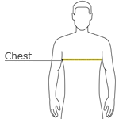

CHEST WIDTH
Measure under the arm and around the fullest part of the chest with arms down, keeping tape horizontal.

SIZE CHART
 | XS | S | M | L | XL | 2XL | 3XL | 4XL
Chest | N/A | N/A | 38-40 | 41-43 | 44-46 | 47-49 | 50-53 | 55-57

